 BartholoMewsings 

St. Bartholomew’s Episcopal Church, P.O. Box 906, High Springs, Fl 32655

<http://www.stbartshighsprings.org/> [www.facebook.com/stbartshighsprings](http://www.facebook.com/stbartshighsprings)

****

March 2024 Vol. XV Issue 3

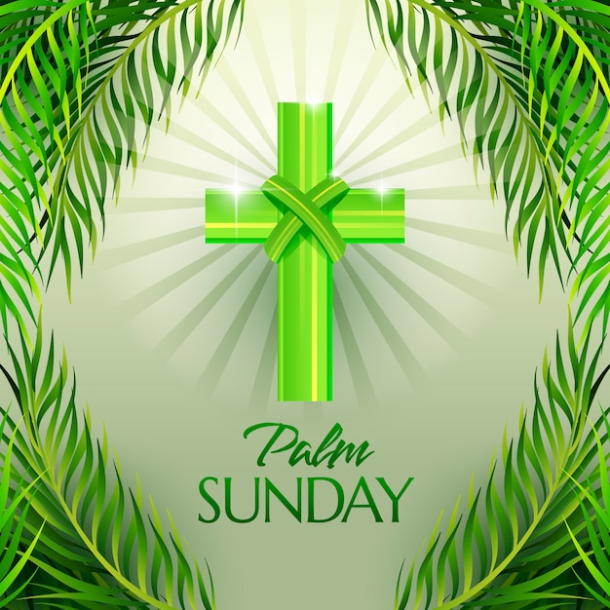

# (The Sunday of the Passion)

The Sunday before Easter, at which Jesus’ triumphal entry into Jerusalem and Jesus’ Passion on the cross are recalled. It is also known as the Sunday of the Passion. Palm Sunday is the first day of Holy Week. The observance of Palm Sunday in Jerusalem was witnessed about 381-384. During this observance there was a procession of people down the Mount of Olives into Jerusalem waving branches of palms or olive trees as they walked. They sang psalms, including Ps 118, and shouted the antiphon, “Blessed is he who comes in the name of the Lord!” The 1979 BCP presents the full title for the day as we know it today, “The Sunday of the Passion: Palm Sunday” (BCP, p. 270). The liturgy of the palms is the entrance rite for the service. The congregation may gather at a place apart from the church and process to the church after the blessing of the branches of palm. The liturgy of the palms includes a reading of one of the gospel accounts of Jesus’ entrance into Jerusalem. The branches may be distributed to the people before the service or after the prayer of blessing. All the people hold branches in their hands during the procession. Appropriate hymns, psalms, or anthems are sung.

The service then changes focus abruptly from the triumphal entry into Jerusalem to the solemnity of the Passion.

Ref: A Dictionary of the Episcopal Church

BD21427_**Editor’s Note:** We hope you are enjoying the Newsletter, and we welcome your comments and suggestions. **Deadline for next issue is** **March 20th.** Contact: Annette Jones - (386) 454-8585 [pgrscoot97@aol.com](mailto:pgrscoot97@aol.com)

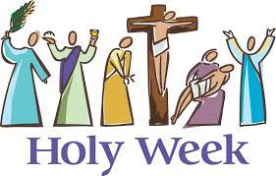

From early times Christians have observed the week before Easter as a time of special devotion. As the pilgrim Egeria recorded in the late fourth century, Jerusalem contained many sacred places that were sites for devotion and liturgy. Numerous pilgrims to the holy city followed the path of Jesus in his last days. They formed processions, worshipped where Christ suffered and died, and venerated relics. From this beginning evolved the rites we observe today on Palm Sunday, Maundy Thursday, Good Friday, and Holy Saturday. These services provide a liturgical experience of the last days of Jesus' earthly life, as well as the time and events leading up to his resurrection. The BCP provides special liturgies for each of these days. Some parishes observe the service of Tenebrae on one of these days in Holy Week. The three holy days, or Triduum, of Maundy Thursday, Good Friday, and Holy Saturday are at the heart of the Holy Week observance. In many Episcopal parishes, the liturgical color for Holy Week from Palm Sunday through Maundy Thursday is red. Holy Week ends at sundown on the Saturday before Easter, or with the celebration of the Easter Vigil.

Ref: A Dictionary of the Episcopal Church

BD10308_

 **Lessons for March** 

**March 3rd:** Exodus 20:1-17;Psalm 19; 1 Corinthians 1:18-25; John 2:13-22

**10th:**  Numbers 21:4-9; Psalm 107:1-3, 17-22; Ephesians 2:1-10; John 3:14-21

**17th:** Jeremiah 31:31-34; Psalm 51:1-13; Hebrews 3:5-10; John 12:20-33

**24th: Palm Sunday:** Isaiah 50:4-9a; Psalm 31:9-16 ; Philippians 2:5-11; Mark 14:1—15:47

**28th: Maundy Thursday:** Exodus 12:1-4,[5-10],11-14; Psalm 116:1,10-17;

1 Corinthians 11:23-26; John 13:1-17,31b-35

**29th: Good Friday:** Isaiah 52:13—53:12; Psalm 22; Hebrews 10:16-25; John 18:1—19:42

**31st: Easter:** Acts 10:34-43; Psalm 118:1-2,14-24; 1 Corinthians 15:1-11; John 20:1-18

Maundy Thursday

The Thursday in Holy Week. It is part of the Triduum, or three holy days before Easter. It comes from the Latin mandatum novum, “new commandment,” from John 13:34. The ceremony of washing feet was also referred to as “the Maundy.” Maundy Thursday celebrations also commemorate the institution of the eucharist by Jesus “on the night he was betrayed.” Egeria, a fourth-century pilgrim to Jerusalem, describes elaborate celebrations and observances in that city on Maundy Thursday. Special celebration of the institution of the eucharist on Maundy Thursday is attested by the Council of Hippo in 381. The Prayer Book liturgy for Maundy Thursday provides for celebration of the eucharist and a ceremony of the washing of feet which follows the gospel and homily. There is also provision for the consecration of the bread and wine for administering Holy Communion from the reserved sacrament on Good Friday. Following this, the altar is stripped, and all decorative furnishings are removed from the church.

BD21427_

# Good Friday

The Friday before Easter Day, on which the church commemorates the crucifixion of Jesus. It is a day of fasting and special acts of discipline and self-denial. In the early church candidates for baptism, joined by others, fasted for a day or two before the Paschal feast. In the west the first of those days eventually acquired the character of historical reenactment of the passion and death of Christ. The liturgy of the day includes John's account of the Passion gospel, a solemn form of intercession known as the solemn collects (dating from ancient Rome), and optional devotions before the cross (commonly known as the veneration of the cross). The eucharist is not celebrated in the Episcopal Church on Good Friday, but Holy Communion may be administered from the reserved sacrament at the Good Friday service.

BD21427_

# Holy Saturday

The Saturday after Good Friday, which recalls the day when the crucified Christ visited among the dead while his body lay in the tomb of Joseph of Arimathea. In the Episcopal Church there is no eucharist on Holy Saturday. The BCP provides a simple liturgy of the word with collect and readings for the Holy Saturday service. The funeral anthem “In the midst of life” (BCP, pp. 484 or 492) is used instead of the prayers of the people (BCP, p. 283). In the ancient church, those preparing for baptism and perhaps others continued the fast they began on Good Friday. Holy Saturday ends at sunset. Fasting and other preparations end at sunset or with the Easter Vigil, which begins the celebration of Easter Refs: A Dictionary of the Episcopal Church



Mew-sings from the Senior Warden……Carol Griffin 386-497-2292

Peace through Prayer

The Wednesday Bible Study Group (9:30-11:00) just finished a three-week discussion on prayer reviewing various Bible verses. It led to some very interesting conversations and reflections.

Prayer is an integral part of my daily routine. When I first wake I thank God for the day he has given me and pray for those on my “prayer list” ending with Psalm 143:8,10; “ **8**Let the morning bring me word of your unfailing love, for I have put my trust in you. Show me the way I should go, for to you I entrust my life…..**10**Teach me to do your will, for you are my God; may your good Spirit lead me on level ground.” When Hugh wakes up we do our shared prayers ending with “Remembering that “**24**This is the day that the Lord has made; let us rejoice and be glad in it.” Psalm 118:24 (NRSV). ” When we get up, I fix breakfast and go to my “special place” to do my daily readings and devotionals. It was Jane’s sitting room and is a quiet and peaceful environment where there are few interruptions and a calmness can settle over me. I find that if I have other commitments that day and do not get to the readings and devotionals (as I did not allow enough time for myself) I feel out-of-sorts until I am able to get to them later that day. However, with all the apps on our phones now we can do this anywhere and I can finish up if sitting in a waiting room. It is not the environment I prefer, but it gets me back-on-track.

Paul’s letters contain many prayers. One in particular, Colossians 1:9-12, laid out what we need to include, request and/or recognize daily in our prayers; knowledge of His will and His wisdom, to lead a life worthy of Him, pleasing to Him, that we bear good fruit, grow in knowledge of Him, receive His strength and especially to express our thanks to Him for all His blessings. Throughout the day we are all given the opportunity to offer up prayers to God (pray continuously) for His wonderful creations (the blue birds that appear out of the bird house in the morning as I head to the garage), His protection (when an accident is averted), a “Godwink” (that lets you know something is not a coincidence or a passed loved one is sending you a message), receiving an unexpected but needed surprise, call or letter. He is with us always and all we need to do is reach out in prayer (just talk with Him) sometimes it’s just a “Thank you” or Help me”. In this hectic world we all need time to rest in peace and restore our minds and bodies. Even Jesus needed time alone to pray; “ **15**But now more than ever the word about Jesusspread abroad; many crowds would gather to hear him and to be cured of their diseases. **16**But he would withdraw to deserted places and pray.” Luke 5:15-16 (NRSV).

I end my day thanking God for all the blessings of the day and reciting my evening prayers; ending with Psalm 4:8 “In peace I will lie down and sleep, for you alone, Lord, make me dwell in safety.” Lent may be a good time to think about your prayer life, reading His word and developing a closer relationship with the One that is always with you and ready to listen and help you.

“And the peace of God, which surpasses all understanding, will guard your hearts and your minds in Christ Jesus.” Philippians 4:7 (NRSV)

This Month’s “Godwink”

[LESSONS and Prayers OF AN ANGELIC SEVEN-YEAR-OLD](about:blank)

“My old car would CONK OUT randomly.

One day the car died as I was driving my seven-year-old daughter to school.

I was STRESSED and started making phone calls!

All of a sudden, the radio CAME BACK on, I tried the engine, and it started!

Pleasantly shocked, I said to my daughter, ‘I don’t know what happened!’

Looking at me with an angelic face, she said, ‘I KNOW what happened Mom. I PRAYED and asked God to help us.’”

Penny Ann

••••

Penny Ann’s daughter innocently believed in the power of prayer. And, it worked!

That should be a lesson for each of us ... to allow ourselves to have the “FAITH OF A CHILD.” As the Bible beckons, let us “become as little children.”

Many good wishes for Godwinks of certainty and comfort.

SQuire

BD21427_

# Easter Vigil

The liturgy intended as the first (and arguably, the primary) celebration of Easter in the BCP (pp. 284-95). It is also known as the Great Vigil. The service begins in darkness, sometime between sunset on Holy Saturday and sunrise on Easter and consists of four parts: The Service of Light (kindling of new fire, lighting the Paschal candle, the Exsultet); The Service of Lessons (readings from the Hebrew Scriptures interspersed with psalms, canticles, and prayers); Christian Initiation (Holy Baptism) or the Renewal of Baptismal Vows; and the Eucharist. Through this liturgy, the BCP recovers an ancient practice of keeping the Easter feast. Believers would gather in the hours of darkness ending at dawn on Easter to hear scripture and offer prayer. This night-long service of prayerful watching anticipated the baptisms that would come at first light and the Easter Eucharist. Easter was the primary baptismal occasion for the early church to the practical exclusion of all others. This practice linked the meanings of Christ's dying and rising to the understanding of baptism

Ref: A Dictionary of the Episcopal Church

BD21427_

Christ is Risen Indeed!

Alleluia!

# Easter

The feast of Christ's resurrection. According to Bede, the word derives from the Anglo-Saxon spring goddess Eostre. Christians in England applied the word to the principal festival of the church year, both day and season. 1) Easter Day is the annual feast of the resurrection, the pascha or Christian Passover, and the eighth day of cosmic creation. Faith in Jesus' resurrection on the Sunday or third day following his crucifixion is at the heart of Christian belief. Easter sets the experience of springtime next to the ancient stories of deliverance and the proclamation of the risen Christ. In the west, Easter occurs on the first Sunday after the full moon on or after the vernal equinox. Easter always falls between Mar. 22 and Apr. 25 inclusive. Following Jewish custom, the feast begins at sunset on Easter Eve with the Great Vigil of Easter. The Eastern Orthodox Church celebrates Easter on the first Sunday after the Jewish pesach or Passover (which follows the spring full moon). Although the two dates sometimes coincide, the eastern date is often one or more weeks later. 2) Easter Season.

Ref: A Dictionary of the Episcopal Church

BD21427_

MC900280500[1]

**Birthdays in March March Anniversaries**

1 – Adam Cason 23 – Stephanie Hencin 19 – Jason & Rosina Dennis

16 –Lisa Rhan 23 – Jane Woodward

20 – Chris Ellison 31 – Mason Ellison

**Congratulations to Each of YOU! If your name does not appear here, please contact your Editor to have *it* added for next time.**

BD21427_

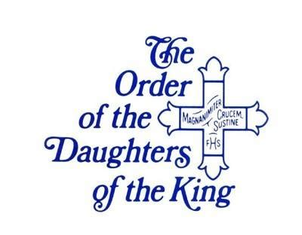A note from DOK

Daughters of The King meeting Mar.2,2024 at 9:30. All women of the church are welcome to visit if they are interested.

For His Sake,

Ann Lundy, President

BD21427_

**Chalice Bearers - March Lay Readers –March**

**3/3 – Neil Boyle 3/3 -- Alex Matisco 3/10 – Alex Matisco 3/10 – Debra Wright**

**3/17 –Stephanie Hencin 3/17 – Sam Tift**

**3/24 –Palm Sunday – Annette Jones 3/24 – Cherie Harris**

**3/28 – Maundy Thursday – No Eucharist 3/28 – Alex Matisco**

**3/29 –Good Friday--Neil 3/29 – TBD**

**3/30 –Holy Saturday – No Eucharist 3/30 – No Reader Needed**

**3/30 – Vigil of Easter – Neil Boyle 3/31 –Charles & Annette Jones**

**Alex Matisco**

BD21427_





Hostess List for March

Mar 3 – Kitchen Crew Mar 10 – Jen and Ruthann

Mar 17 – Carol and Susan Mar 24 – Cornelia S & Jane

Mar 31 No Church services **HAPPY EASTER**

**If you would like to volunteer to provide a light snack and drink, please contact Nancy Brewer at 386-496-3445.**

BD21427_

 Sunday School Schedule for March 

**March 3:    Diane & Diana March 10:  Pete & Jane**

**March 17:  Diane & Diana March 24:  Pete & Jane**

**March 31:  Stephanie & Becky**

LADIES NIGHT OUT.

Diane Shimek welcomed the ladies of St. Bart's to her home in February and a good time was had by all.

 As always, some of the ladies entertained us with song and dance and there is never a lack of conversation and fellowship.  My sister-in-law, Jan, was visiting that weekend and attended with me.  She had met many of the women on previous visits so I was surprised at the number I introduced her to that she hadn't previously met (there were 9!!!) and that does not include all the newbies since her last visit.

 We have really grown in the past few years that is due to the friendly, welcoming, and loving people we have at St. Bart's.   Thank you all and Ladies, if you missed this outing, there will be more, and we hope to see you then.

And now, a little humor…

Born an Episcopalian

Submitted

Each Friday night after work, Ole would fire up his outdoor grill and cooked venison steak.  But, all of Ole’s neighbors were catholic…And since it was the season of Lent, they were forbidden from eating meat on Friday.

The delicious aroma from the grilled venison steaks wafted over the neighborhood and was causing such a problem for the catholic faithful that they finally talked to their priest.

The Priest came to visit Ole, and suggested that he become a catholic.  After several classes and much study, Ole attended Mass…and as the priest sprinkled holy water over him, he said, “You were born an Episcopalian, and raised an Episcopalian, but now you are catholic.”

Ole’s neighbors were relieved, until Friday night arrived, and the wonderful aroma of grilled venison filled the neighborhood.

The Priest was called immediately by the neighbors and, as he rushed into Ole’s yard, clutching a rosary and prepared to scold him, he stopped and watched in amazement.  There stood Ole, clutching a small bottle of holy water which he carefully sprinkled over the grilling meat and chanted:  “You vuz born a deer, you vuz raised a deer, but now you is a walleye.”

BD21427_

**NOTE:** 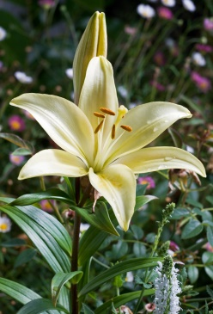Easter Lilies and Poinsettias have always been $10.00 per plant. This past December the cost was over what we actually collected for the Poinsettias. With excess funds from donations, we were able to cover this additional expense. We have tried to find out the cost for the lilies, but stores do not know the price at this time. Annette always checks around and finds the best price. We will continue to take your orders but want you to know it may be a few extra dollars. Thank you for understanding. The plants always make these important services on our church calendar look festive. With many visitors on these special holidays (95 last Easter!!!) it is a nice addition as well as a time to honor/remember our loved ours.

**- - - - - - - - - - - - - - - - - - - - - - - - - - - - - - - - - - - - - - - - - -- - -- - - - - -- - -- - - - - - - - - - - - - - - - - - - - - - - -- - - - - -**

**St. Bartholomew’s Episcopal Church**

**Easter Lilies Order Form**

Name\_\_\_\_\_\_\_\_\_\_\_\_\_\_\_\_\_\_\_\_\_\_\_\_\_\_\_\_\_\_\_\_\_\_\_\_\_\_\_\_\_\_\_\_\_\_\_

Telephone number\_\_\_\_\_\_\_\_\_\_\_\_\_\_\_\_\_\_\_\_\_\_\_\_\_\_\_\_\_\_\_\_\_\_\_\_\_\_

Number of **Easter Lily plants** ordered at a cost of **$10.00**

each\_\_\_\_\_\_\_\_\_\_\_\_\_\_\_\_\_. **Check or cash** **must accompany order.**

Make checks payable to “St. Bartholomew’s” and put “Easter lily” in memo line.

Turn completed form in to church office or mail to:

PO Box 906

High Springs, FL 32655

Is your plant in honor ?\_\_\_\_\_\_\_\_\_\_\_\_\_\_\_\_\_ or in memory ?\_\_\_\_\_\_\_\_\_\_\_\_\_\_\_\_\_\_

Name of loved one(s)\_\_\_\_\_\_\_\_\_\_\_\_\_\_\_\_\_\_\_\_\_\_\_\_\_\_\_\_\_\_\_\_\_\_\_\_\_\_\_\_\_\_\_\_

Thank you for your order. These Easter lily plants will be used to beautify our sanctuary during the Easter Holiday. You may take them home afterward to plant in your flower garden.

Please be careful to write clearly when filling in your form so that your loved one’s name can be read correctly at Easter. Turn in, along with your check or cash, to Carol Griffith or Nancy Brewer. If neither is available, place the form and money in an envelope, and leave it in the offering plate.