 BartholoMewsings 

St. Bartholomew’s Episcopal Church, P.O. Box 906, High Springs, Fl 32655

<http://www.stbartshighsprings.org/> [www.facebook.com/stbartshighsprings](http://www.facebook.com/stbartshighsprings)

****

March 2021 Vol. XII Issue 3

**Vicar’s Message**

***May the grace, peace, and love of our Lord Jesus Christ be with you!***

All Christian seasons have a special purpose, and the penitential season of Lent sets the stage for a meaningful Easter. It is good to periodically check on our wellbeing. An annual checkup with the doctor is good for physical health. A check up on our financial plans that usually occurs in support of our taxes can identify if our financial plans need adjustment. The most important check up we often neglect is our spiritual wellbeing. Without spiritual health all the other efforts don’t produce a happy ending. Our Lord Jesus Christ says: “Thou shalt love the Lord thy God with all thy heart, and with all thy soul, and with all thy mind and with all thy strength; this is the first commandment.” (Mark 12.30 KJV) Worship, prayer, and Bible study are essential to fulfilling the first commandment. How are we doing in our worship, prayers, and Bible study? What changes are needed in our lives? This is the Lent task at hand for all of us.

We have started a veteran’s memorial wall to recognize our church members that have served our great country and community in the military or as a Department of Defense civilian or as local police or fire department members. Thank you Tom Crossman for donating the memorial flag and plaque. If you are a veteran please provide your name, branch or type of service, rate and/or rank, and period of service to either Carol or myself.

The Board decided that we will not be holding a VBS program this summer. COVID remains an unknown and usually by now we have already started the planning and investing in resources. At the Diocesan Convention this year Camp Weed announced that it is moving forward with summer camp planning. Please check the Camp website for information and contact me if interested.

I am so very pleased with the progress that our Daughters of the King (DOK) have made in their return to service. The membership is growing. The DOK normally meets on the first Saturday of the month at 9:30 am in the parish hall. If you are curious about DOK you are welcome to attend a meeting. Contact Peggy Addington if you have any questions.

Planning is underway for the celebration of the 125th anniversary of our church to be held November 6 and 7. This is an excellent opportunity to get involved and make new friends. Contact Jane Woodward or Ruthann Swanson for more information.

I pray that we will be able to return to the Sanctuary for or maybe before Easter. Herd or population immunity i.e. that point where the infections decline and the immunization keep it in check will definitely affect our opening up for services. The vaccine and natural immunity appears to be working. Masks will be required, sanitizing continued, and we will encourage social distancing by sitting with family members. Needless to say anyone that is at risk due to other factors or for any reason is not comfortable attending should consider remaining at home. Our 8 am service is normally low in attendance and could be an option. I strongly support getting the vaccine to significantly improve your odds of not getting a serious case of the COVID flu or for spreading it. Wash, wash, wash and pray, pray, pray.

If you have not submitted your pledge form please do so. This form tells me you are a subscribing (committed) member supporting Jesus Christ’s work in the church. It is part of being in good standing. How much you pledge is a matter of your heart and not seen by me.

Much love in Christ, fr lance+

BD21427_

**Editor’s Note**

. We hope you are enjoying the Newsletter and we welcome your comments and suggestions.

**Deadline for next issue is** **March 20th**

Contact: Annette Jones - (386) 454-8585 [pgrscoot97@aol.com](mailto:pgrscoot97@aol.com)

*Highlights from the St. Bart’s Annual Meeting 2/21/21*

* ***Mission Board Election*** *The Mission Board consists of: Fr. Lance, Vicar, Carol Griffin, Senior Warden, Joe Scianimanico, Junior Warden, Neil Boyle, Treasurer, Ladd Harris, Kalynn Matisco and Jane Woodward. Annette Jones serves as Clerk.*
* ***Convention Delegates Election***  St. Bart’s, as a Mission Church, is entitled to 2 delegates. Our delegates elected to attend the 2022 Diocesan Convention are Alex and Kalynn Matisco. The alternate delegates are Neil and Sue Boyle.
* ***Treasurer’s Report*** Thus far this year’s pledges are down and if you have not yet turned in your pledge form, please get it in to the treasurer as soon as convenient. The current budget, approved at the

Annual Meeting is posted on the bulletin in the parish hall.

* ***Annual Parish Report***  Fr. Lance began his twelfth year with us as this month (Feb). Even though this has been a difficult year due to the pandemic our mission church participates in Diocese programs, has two services each Sunday: 8am and 10am, and is back to celebrating a complete church year including the Great Easter Vigil. We baptize and confirm and also reach out into our community.

**Note:** Should you desire more information, a complete copy of the minutes of the Annual Meeting of St. Bartholomew’s Episcopal Church will be posted on the bulletin board in the Parish Hall.

BD10308_



Mew-sings from the Senior Warden……Carol Griffin 386-497-2292

For those of you who were unable to attend the Annual Church meeting on February 21st, you missed some informative presentations. Our Treasurer, Neil Boyle, presented the Budget for 2021. While the bottom-line leaves us short in meeting our expenses based on the Annual Stewardship Forms that we received and our projected expenses, it is not unsurmountable and with the generosity of each of you, I know we will meet our obligations. The 2021 Budget and 2020 Financials are posted in the Parish Hall for your review.

If you did not complete a Giving Form, it is not too late. They are located in the Parish Hall for your convenience.

Our Jr. Warden, Joe Scianimanico, gave an update on the Sanctuary Project. The work to raise up the Church has been completed and we will be looking at the next steps to be taken in order to preserve this historic gem. There are pictures and information on the work completed in the Parish Hall.

Alex Matisco, with the help of Ken Davies, prepared a presentation for the Memorial Garden. The Mission Board, after reviewing the bids for the project, selected Evergreen Lawn Care for the project. A rendition of the Garden along with proposed plants also is in the Parish Hall for your viewing. More information will be forthcoming on the Garden, but if you have any questions, do not hesitate to contact any member of the board or Alex.

Last but not least, Ruthann Swanson gave an update on the 125th Anniversary Celebration to be held in November. We have received confirmation that Bishop Howard will be joining us for the two-day event. Jane Woodward and Ruthann are planning a fun-filled weekend with many activities, guest speakers, a BBQ competition, music and much more. As we get closer to the event, we will be calling on the entire congregation to offer their “talents” and volunteer.



[**DOGWINK SPOTTY – LOUISE’S BEST FRIEND**](https://godwinks.com/blogs/squires-blog/dogwink-spotty-louise-s-best-friend)

Louise was one of those kids who was painfully shy.  She felt more comfortable with animals than people.

Every Christmas she’d write her WISH LIST and at the very top were three big letters D-O-G.

She knew it was a long shot … since her mother had a fear of dogs. Sadly, Louise's GRANDFATHER had died tragically from a RABID dog BITE.

One day her mother was having a very STRESSFUL TIME with a MIGRAINE headache. Without thinking, Louise once again asked her mom if she could have a dog.

Her mom quickly blurted, “the ONLY way you’re going to get a dog … is if someone leaves it to you in their WILL.”

Louise felt wounded. She went to her room and PRAYED about it.

But, most of us know from experience, that from every bad thing that happens to us, God usually births SOMETHING that’s good. Sometimes … a Godwink … one of those little coincidences that isn’t coincidence, but comes from divine origin.

Here’s what happened to Louise. Their neighbor Bill had an elderly mother who needed a dog sitter. Knowing how much Louise loved dogs, Bill HIRED HER for the job.

When Louise laid eyes on SPOTTY, it was love at first sight. That little border collie helped EASE Louise’s HEARTACHE of not having her own dog.

Months later, Bill knocked on their door and said he had some SAD NEWS. His mother passed away but she left something for Louise in her will.

Louise and her Mom stood in the doorway, wondering what it could be, as Bill walked to his car.

He opened the car door and OUT JUMPED SPOTTY wagging her tail!

Louise’s eyes filled with happy tears! Ever so gently she looked up at her mom … ASKING if she could KEEP SPOTTY.

Her mother was quiet … for what seemed like an eternity.

Reluctantly, she answered, “Well … I guess I don’t have a choice … since the DOG was left to you in a will!”

What a wonderful Godwink/Dogwink!

For the next 14 years Louise and Spotty were INSEPARABLE …  and EVEN MAMA got to LOVE SPOTTY … almost as much as Louise.

Wishes for Winks ... Squire

February, 2021 SQuire Rushnell

***Reminder***, - do not forget to submit your “Name That Band” form by March 12th and claim the remarkable prizes that come with winning the name.

Coming together as a family is what really makes St. Bart’s shine. It is why we all know how special our “BIG little” Church is and we want others in the High Springs community to experience our fellowship. We will demonstrate by example.

***“****How very good and pleasant it is when kindred live together in unity!” Psalm 133:1 (NRSV).*

***And Another Reminder*** – We will be updating the St. Bart’s Directory this year. A list of the members in the old directory is on the bulletin board (with a pen) for your review, corrections and additions. Please take a moment to verify the information we currently have. If you are not on the list, email Neil Boyle ([nsboyle@nsboyle.com](mailto:nsboyle@nsboyle.com)) or Carol Griffin (cfgriffin7@aol.com). Thank you.

BD21427_

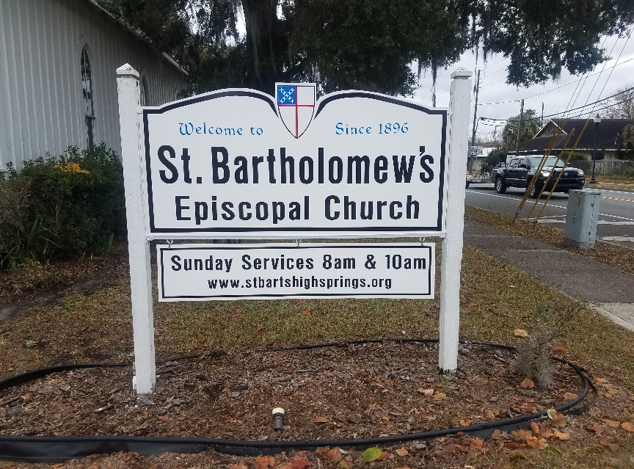

*Have you noticed the beautiful new sign proclaiming our church’s presence outside the sanctuary?*

*Thanks for the generosity of the members of our church family for this new improvement.*

BD14997_

In March 1995 St. Bartholomew’s began publishing its own newsletter, “The Mustard Seed” with Katherine Williams as Editor. A contest was held to name the publication. The prize was a one-year subscription and a free lunch on covered-dish Sunday.

Keeping up with tradition for St. Bartholomew’s 125th Anniversary on November 6, 2021, We are having a “Name That Band Contest.” The winner will receive A free subscription to “BartholoMewings” and a free meal on Potluck Sundays.

**Let’s have fun with this.**

Name That Band Contest

For St. Bartholomew's 125th celebration on November 6th,

Ladd and Cherie will be performing.

We need a name for Ladd and Cherie's band.

Submit your entry to - [stbartshs@gmail.com](mailto:stbartshs@gmail.com) or fill out entry form at the back of church and give to Ruthann or Jane

Unlimited entries.

**Deadline for Entry - March 12th**

Winner will receive:

     1. One full year subscription to St. BartholoMewsings.

     2. One free meal on Potluck Sundays.

Ladd and Cherie will decide on the winning name.

Band Name\_\_\_\_\_\_\_\_\_\_\_\_\_\_\_\_\_\_\_\_\_\_\_\_\_\_\_\_\_\_\_\_\_\_\_\_\_\_\_\_\_\_\_\_\_\_\_\_\_\_\_\_\_\_\_

Submitted By \_\_\_\_\_\_\_\_\_\_\_\_\_\_\_\_\_\_\_\_\_\_\_\_\_\_\_\_\_\_\_\_\_\_\_\_\_\_\_\_\_\_\_\_\_\_\_\_\_\_\_\_\_

BD21427_

 **Lessons for March** 

**March 7th:** Exodus 20:1-17;Psalm 19; 1 Corinthians 1:18-25; John 2:13-22

**14th:**  Numbers 21:4-9; Psalm 107:1-3, 17-22; Ephesians 2:1-10; John 3:14-21

**21st:** Jeremiah 31:31-34; Psalm 51:1-13; Hebrews 3:5-10; John 12:20-33

**28th: Palm Sunday:** Isaiah 50:4-9a; Psalm 31:9-16 ; Philippians 2:5-11; Mark 14:1—15:47

**Holy Week:**

**29th: Monday:** Isaiah 42:1-9; Psalm 36:5-11; Hebrews 9:11-15; John 12:1-11

**30th:Tuesday:** Isaiah 49:1-7; Psalm 71:1-14; 1 Corinthians 1:18-31; John 12:20-36

**31st:Wednesday:** Isaiah 50:4-9a; Psalm 70; Hebrews 12:1-3; John 13:21-32

**April 1st:Thursday:**Exodus 12:1-4, (5-10) , 11-14; Psalm 116:1, 10-17; 1 Corinthians 11:23-36; John 13:1-17, 31b-35

**2nd: Friday:** Isaiah 52:13—53:12; Psalm 22; Hebrews 10:16-25; John 18:1—19:42

**3rd: Saturday:** Job 14:1-14; Psalm 31:1-4, 15-16; 1 Peter 4:1-8; Matthew 27:57-66

**We will save the Easter Readings for next month’s newsletter.**

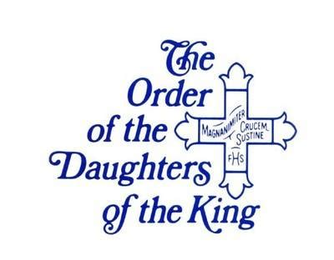

A note from DOK

Our February meeting was very exciting as we welcomed three ladies studying to join our order. Diana Cason, Anne Lundy and Becky Tift. There will be an induction ceremony April.

Our welcoming gifts for visitors of hand sanitizer and bottles of honey have been readied. Thanks to all for help in making these gift bags.

We’re now looking forward to our March meeting, Saturday, March 6 @9:30. All ladies of Saint Bart’s are welcome to attend and if any are interested in joining our order, please attend.

In His Name,

Peggy Addington, President DOK

BD21427_

MC900280500[1]

**Birthdays in March Anniversaries**

1 – Adam Cason 19 -- Chris Ellison 6 – Richard & Cornelia Swann

7 – Edgar Carrasco 21 -- Cole Diepersloot 19 – Jason & Rosina Dennis

15 – George Edwards 23 – Stephanie Hencin

16 – Lisa Rhan 23 – Jane Woodward

16 – Alex Scianimanico 31 – Mason Ellison

19 –Melanie Davis

**Congratulations to Each of YOU! If your name does not appear here, please contact your Editor to have *it* added for next time.**

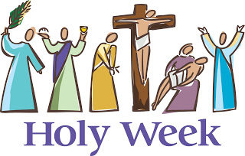**Holy Week starts with Palm Sunday** Jesus was welcomed by the people with cheers and palms - a symbol of victory and sign that "all is well". Palm-bearing date trees were valued for their dignity, beauty and shade and were used at special occasions to welcome heroes and royalty. As you listen to the Passion on this day, place yourself in the story. What does it feel like to be part of the crowd or to be a disciple? What does it feel like to be in Jesus' place during the passion?

BD21427_

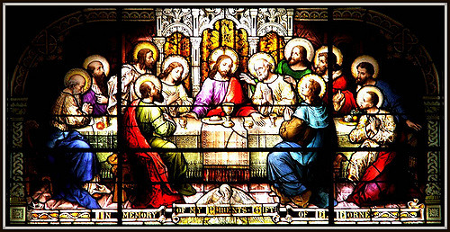 **Holy Thursday, Mass of the Lord's Supper** Tonight's first reading describes the Passover meal. In the second reading, the institution of Eucharist is shared, "this is my Body, which is for you." In the Gospel, Jesus washes the feet of the disciples. This is the service and love of Jesus, which we are asked to share in our lives. On Holy Thursday, we experience the washing of the feet: Put yourself in the place of the foot-washer: How do you feel washing the feet of others? Put yourself in the place of the disciples: How does it feel to have someone, who means so much to you, wash your feet?

BD21427_

**Good Friday of the Lord's Passion** The first and second readings, from Isaiah and Paul's letter to the Hebrews, describe the mystery of the cross - the Paschal Mystery - suffering turned into victory. The gospel is the Passion of Our Lord Jesus Christ. The word passion can also mean strong feelings of love. Jesus' passion is the time from the Last Supper to his death on the cross, during which he shows his great love for us. If you stood at the cross on which Jesus hung, what would you say to him? How does it feel to touch or kiss the cross? What does this mean to you?

….to be continued next month.

****

**St. Bartholomew’s Episcopal Church**

**Easter Lilies Order Form**

Name\_\_\_\_\_\_\_\_\_\_\_\_\_\_\_\_\_\_\_\_\_\_\_\_\_\_\_\_\_\_\_\_\_\_\_\_\_\_\_\_\_\_\_\_\_\_\_

Telephone number\_\_\_\_\_\_\_\_\_\_\_\_\_\_\_\_\_\_\_\_\_\_\_\_\_\_\_\_\_\_\_\_\_\_\_\_\_\_

Number of **Easter Lily plants** ordered at a cost of **$10.00**

each\_\_\_\_\_\_\_\_\_\_\_\_\_\_\_\_\_. **Check or cash** **must accompany order.**

Make checks payable to “St. Bartholomew’s” and put “Easter lily” in memo line.

Turn completed form in to church office or mail to:

PO Box 906

High Springs, FL 32655

Is your plant in honor ?\_\_\_\_\_\_\_\_\_ or in memory ?\_\_\_\_\_\_\_\_\_\_\_

Name of loved one\_\_\_\_\_\_\_\_\_\_\_\_\_\_\_\_\_\_\_\_\_\_\_\_\_\_\_\_\_\_\_\_\_\_\_\_

Thank you for your order. These Easter lily plants will be used to beautify our sanctuary during the Easter Holiday. You may take them home afterward to plant in your flower garden.

Please be careful to write clearly when filling in your form so that your loved one’s name can be read correctly at Easter. Turn in, along with your check or cash, to Carol Griffith or Nancy Brewer. If neither is available, leave in Fr. Lance’s office.